OUR X FACTOR
THE POWER TO ACHIEVE—EVERY DAY—SUCCESS AND HAPPINESS
BY
XAVIER VAN DE LANOTTE

PRESS KIT

TABLE OF CONTENT:
- Why this book
- Endorsements
- About the Book: Goals, Audience and Structure
- OURXFACTOR—Mobile APP (Mindfulness, Gratitude and Compassion)
- Author Biography (and Contact Info.)
- Press Release
- Sample Passages of the Book
- Frequently Asked Questions
- Book Information
- Promotion and Future Steps
WHY THIS BOOK?
Everyone needs a secret weapon, an X factor, and we hold it within. This book inspires us to reveal that weapon and, soon, to love our lives and thrive in all that we decide to do with them.
Life is an easy and enjoyable process. OUR X FACTOR simplifies our lives and provides insights and guidance to steer us the right way: relish the fruits of our contributions, enjoy the paths we chose, and create and share the destinies and legacies we forge and desire.
This book is meant for anyone wishing greater success and happiness and to overcome hurdles.
While most success or happiness books address faith, habits or can-do attitudes, philosophical discourse, positive thinking, or clinical, scientific and psychological evidence as their foundation, Our X Factor offers three perspectives by which to guide our lives; yet it captures the knowledge, wisdom, logic, science or psychological discoveries found within these other books.
Why three distinct perspectives?
Success and happiness, for each one on of us, hinge on the existence of three cornerstones:
(1) Awareness to overcome challenges that we meet in our paths toward achieving our goals,
(2) Goal clarity and ability to achieve, based on our resource accessibility and potential, and
(3) Motivation to pursue goals AND processes to get started, endure, and support to succeed.
Our X Factor addresses each one in the three parts of the book, to offer a comprehensive view on how to maximize our potential and to optimally explore our arsenal of positive emotions.
The book contains many insightful citations; points to numerous reference materials, sources and related resources; and features real life stories and biographical examples of well-known individuals, whose actions and attitudes depict qualities associated with success and happiness.
More than a traditional self-improvement book, Our X Factor is a practical guide to becoming one’s own life coach and to provide the tools and inspiration to embrace our success and happiness, every day forward, for the rest of our lives.
Note: Success and happiness work hand in glove. Without achieving the things that are important to us, we never experience the satisfaction of contributing in a meaningful and rewarding manner to enrich our lives and the lives of those around us. Likewise, without enjoying and experiencing passion for what we do, we don’t achieve results marked with the quality and excellence deserving of our success.
ENDORSEMENTS
Laura BUEGE, Marketing Professional and Visionary; Smyrna, GA
Our X Factor is a marvelous ready-reference to read again and again to help maintain focus when life – in all its glorious ups and downs – leaves you questioning ‘why?’ and ‘what next’? The concept that you have free will to choose happiness and satisfaction is not new. What is new and different about ‘Our X Factor’, however, are the many analogies and quotes that you can parallel to your own professional and personal life challenges. You are not alone in your suffering and quest for happiness, yet you are the only one who can discover your X Factor. You will thoroughly enjoy the well-weaved story telling throughout and feel more empowered by the last page.
Petra Andres, Leadership Coach; Frankfurt, Germany
We are all extremely busy and we tend to lose sight of what is important and what really matters in our lives. Our X Factor is a fast-paced book that explores the many reasons why this happens--through examples and stories. I found it easy to relate to the people I "met" in the course of the book and felt like I am not alone in my struggles. Our X Factor gives step-by-step guidance on how to explore your situation, get reacquainted with your priorities and then pursue them. I recommend this book to anyone who wants to (re)discover their true core and live it, too.
Gilles Genre-Grandpierre, Regional Manager, Agence Française de Développement; Dominican Republic
Our X Factor is a very well written book packed with insights and references to support anyone in any situation—personal, professional, relational, social or spiritual—that I recommend to all. The stories, citations and examples throughout the book are relevant and compel the reader to reflect about his or her choices, desires and goals and discover new perspectives that bring peace of mind and lead to positive outcomes. Moreover, for those leading busy lives or feeling satisfied with their lives, Our X Factor bridges the gap toward our understanding of others and the world, which helps in guiding our interactions accordingly. One of the better personal development books I have read in years, Our X Factor delivers, page after page, on its promise to brighten our future and that of those around us.
Giancarlo Nacinelli, Author, Entrepreneur and Coach; Pesaro, Italy
As a coach and instructor in public speaking and leadership, I notice people’s mental blocks, fears, or lack of confidence. The Author, Xavier Van de Lanotte, skillfully illustrates in this book the issues and mental processes that keep us from performing at our very best. Our success and confidence hinge first and foremost on what we believe we can achieve. Chapter after chapter, Our X Factor challenges our perceptions and suggests strategies to increase our potential, accomplish our goals, and be the best that we can be. There is no point in going on in a direction we are displeased with. This book shows us how to make that change.
Efren Baldéon, Entrepreneur and Ret. Executive; Miami, Florida
I practice yoga and meditation to focus and clear my mind of unnecessary distractions, consult leadership and motivational books to guide my actions, and read about eastern philosophy to manage my emotions. Our X Factor provides all this. It inspires serenity, optimism and love and raises confidence. It is a hands-on reference to foster a sense of purpose and direction, prioritize things necessary to sustain balance in life while fulfilling dreams and rekindling faith in all that can be done and is good. Less esoteric or dogmatic than most books in this genre, Our X Factor is possibly the most spiritual book of all books not claiming to be one. Useful, insightful, inspiring, memorable, witty, filled with spirited thought-provoking stories, it is easy and fun to read. I suggest this book for all audiences, regardless of age, gender, origin, preferences and beliefs.
Luisa Echeverri, Fan of Our X Factor; Lyle, Washington
"This is a wonderful book, I was introduced to it about 6 months ago, I was going through a lot , and I bought it but was not constant with it, I had big decisions to make about my children, my family and myself . After the decisions were made ,not from me, but from certain events, I started reading it and once I got into it, I couldn't stop, every chapter had something that I could relate with, I have made big changes in myself, learn how to control emotions and not worry or loose myself for what I can't change. Xavier Vandelanotte has made a big difference in my life. And I really hope people get their hands on "our x factor", it is one of the best investments I have made for myself, and the price is very low for what it can do, better than paying a physiologist a bunch of money, when on this book you can feel the writer, and how he leaves a piece of himself in each chapter. .. I started to read it again 2 days ago. .. Thank you and my biggest respect for you, for carrying for people and for making a difference. Xavier Van de Lanotte. ...you are unique. Hopefully soon we’ll be reading. .."Our X Factor 2."

ABOUT THIS BOOK (Goals, Audience and Organization)
Our X Factor opens our eyes to our potential and unique perspectives to accomplish with greater ease what we choose to do in life and to experience happiness. Our X factor unleashes our courage and confidence in pursuit of our goals, purpose, and emotional wellbeing.
The book is designed for all audiences, wishing to improve their lives, increase their joy and happiness, and achieve better and sustainable results. Audiences of particular interest:
1. Young people (16-30) searching to determine what to do in life;
2. People experiencing life-changing events, lacking confidence, feeling isolated or stuck;
3. Individuals who are unhappy with their jobs, in their lives or with their relationships; and
4. Anyone wishing to enrich their lives, or help loved ones overcome life situations and succeed.
The book has a Foreword, Introduction and 24 chapters organized in three parts, each with a unique style and own objective, leading to the same goals. Each part can be read independently (as in three books contained in one).
Part 1: AWARENESS (Chapters 1 through 13)
Identifies and remedies what slows us down, weakens us, skews our perceptions, or hurls us into obstacles, as things occur in our environments as well as within us.
Ten major themes convey, through a collection of stories and examples, what is necessary to tune our perspectives, attitudes and actions, in a direction to achieve optimal performance, greater success and happiness.
Part 2: MAKING IT HAPPEN (Chapters 14 through 20)
Focuses on the discovery and formulation of our purpose and development of our potential.
Two chapters define ‘Our X Factor’ and ‘The Value Chain of Success and Happiness’, while five chapters explore the tenets of the value chain: Purpose, Excellence, Potential, Environment, and Collaboration. Inspiring celebrity stories illustrate how to manage the value chain for our success and happiness.
Part 3: MAKING IT COUNT (Chapters 21 through 24)
Examines elements of success and happiness and their significance for our lives.
The final chapter recommends how to contribute daily to forging our goals and sustaining feelings of happiness, and is supported with a Mobile APP.

OURXFACTOR—Mobile APP (Gratitude, Compassion and Mindfulness)
A free Mobile APP was developed (for free) by a Company and its development team who was inspired by the book Our X Factor, and is based on Chapter 24’s “The Day in a Life Challenge”.
The challenge encourages a few minutes of reflection at the beginning and ending of each day, to respectively plan and assess our activities for each day. The APP facilitates a self-rating regarding five objectives achieved while reviewing what transpired throughout our day:
- How we managed our emotions
- What we did to progress with our goals
- What we did to develop our potential (and the value of our contributions)
- How we improved our relationships and interactions
- How much gratitude and compassion went in our decisions and interactions
A simple rating scale measures our performances against our standard behaviors. Over time, this ritual exercise, which takes but two or three minutes a day, fosters our gratitude, our compassion and our mindfulness.
It is available online at the Apple AppStore. The APP includes some additional helpful features. As the user-base grows, the APP will be upgraded with more features and graphics and made available on other platforms.

AUTHOR BIOGRAPHY (and contact info.)
Xavier, Belgian born, has worked, lived, and studied in several countries and held a variety of management positions in education, sales, marketing, public relations, strategy, finance, and corporate development and training. His focus is on understanding people in their environment and, from there, identifying the least resistant path to develop effective and collaborative approaches for success.
He is devoted to improving people's lives. He coaches people and organization and also provides strategy development consulting services, catering to companies whose environments evolve at high velocity or seek to operate with greater efficiency. He is published in leading professional publications, both in his name and as a ghost writer for a Dow Jones-listed company.
Xavier raises three teenage children in southern Florida. In his spare time he enjoys cycling, sailing, music and photography and teaches tennis. He also blogs and writes novels as well as about business, social and emerging issues.

PHOTOGRAPH
Xavier Van de Lanotte
Author, Our X Factor
CONTACT INFORMATION
Address: 12801 SW 71st AVE
MIAMI, FL 33156 - U.S.A.
Phone: +1-305-972-4517
E-Mail: Xavier@OurXFactor.com
and Xavier@VXTConsulting.com
Ordering and book information at:
www.OurXFactor.com
ADDITIONAL PICTURES
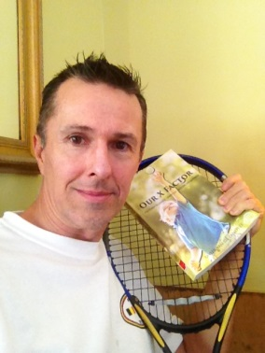
1- Book and Tennis 2- Miami Int’l Book Fair
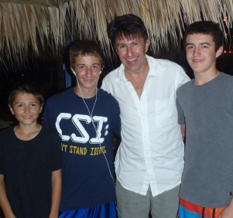
3- Book Signing 4- With my three sons
Home with Celebrating 50
Construction Workers Florida Keys

PRESS RELEASE
Xavier Van de Lanotte’s new book “Our X Factor: The Power to Achieve—Every Day—Success and Happiness” is a triumphant clarion call for everyone to seek greatness.
New book “Our X Factor” from Page Publishing author Xavier Van de Lanotte is an electrifying practical guide to success and happiness. Those seeking purpose, joy, and excellence will find the path to their future within the pages of this insightful and well-crafted work of art.
“Our X Factor’s” unique three-pronged approach to the subject fosters the quintessential attitudes needed for people to love life and optimize efforts to achieve maximal satisfaction with the fulfillment of goals and dreams, while also lifting outlooks and relieving stress, frustration, bad habits, tempers, shortage of time and lack of enjoyment pertaining daily routines, caused by their increasingly demanding and hectic lifestyles. It is rich in inspirational quotations, references, stories, examples and anecdotes that the author uses to highlight throughout the book the behavioral, psychological and philosophical aspects of people’s quest for success and happiness.
Giancarlo Nacinelli, Italian Bestselling Author of motivational book "Io Sono, Io Posso", and founder and retired CEO of SuperLearning S.R.L., Italy's premier institution for public speaking, memorization and leadership training, weighs in with his review of the book: “Our success and confidence hinge first and foremost on what we believe we can achieve. Chapter after chapter, ‘Our X Factor’ challenges our perceptions and suggests strategies to increase our potential, accomplish our goals, and be the best that we can be.”
Xavier Van de Lanotte, a Renaissance man and seasoned international business professional, has completed his inspiring book “Our X Factor”: a tome of knowledge abounding with wisdom garnered from years of professional experience at the cutting edge of business, management, and interactions with people across cultures and points of view.
Published by New York City-based Page Publishing, Xavier Van de Lanotte’s eye opening new book will provide any individual with the keys necessary to unlock perspectives at an entirely new plane of existence, performance, and satisfaction.
According to Aristotle, “happiness is the meaning and purpose of life, the whole aim and end of human existence.” Some people go to great lengths just so they can secure happiness for themselves, but they often mistake transient pleasures and lofty achievements for happiness, not realizing that being happy is more a choice and a process than an end product. Author Xavier Van de Lanotte, in this era of increasing mindfulness, takes on the noble task of guiding the perennial seekers of happiness or success to the right path, which is paved with moments of self-examination, life-changing decisions, and questions that will haunt them until they are able to put things in perspective: “What makes you happy? What do you want to achieve in your life? How do you feel about the direction you are on? Are you confident with your choices and pleased with your success every day?” Readers groping for answers and yearning to live life to the fullest will thoroughly enjoy this book.
Readers who wish to experience this edifying work can purchase “Our X Factor” at bookstores everywhere or online at the Apple iTunes store, Amazon, Google Play or Barnes and Noble.
For additional information, visit www.OurXFactor.com, or for media inquiries, contact Page Publishing at 866-315-2708.
About Page Publishing
Page Publishing is a traditional New York based full-service publishing house that handles all of the intricacies involved in publishing its authors’ books, including distribution in the world’s largest retail outlets and royalty generation. Page Publishing knows that authors need to be free to create - not bogged down with complicated business issues like eBook conversion, establishing wholesale accounts, insurance, shipping, taxes and the like. Its roster of authors can leave behind these tedious, complex and time consuming issues, and focus on their passion: writing and creating. Learn more at www.pagepublishing.com.

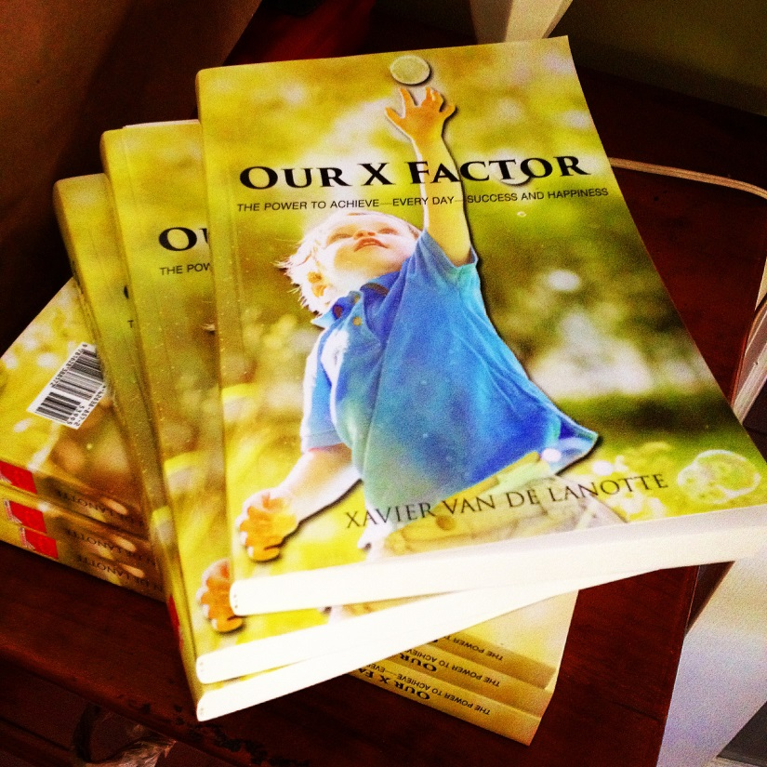
SAMPLE PASSAGES OF THE BOOK
Excerpt from Part 1, Chapter 12: Connecting the Dots (on Legacy)—towards end.
We can determine today the person we want to become and be that person right now, for there is no reason not to. There is no reason not to be the charming, warm, and caring individual we want to be. There is no reason to wait to be happy until we find the loves of our lives, our dream jobs, our new homes, or the beautiful cars, objects and holidays for which we long. There is no reason not to be generous and attentive with our loved ones or to wait until they change their attitudes toward us to show them that we care. There is no reason to go on suffering because people hurt us or because we regret having made mistakes. We can accept, forget, forgive, apologize, and move on.
Let’s not wait for others to make up their minds, for the weather to change, or for the sun to appear to go outside and live our lives. We can stop making excuses to postpone doing the things we want to do or learning the things we always wanted to know more about. Let’s resolve ourselves to decide and to just do it, because a decision without action is nothing at all.
With each hesitation and each day going by without acting on our desires, we put our lives on hold, and we feel bad because the things we want aren’t coming into our lives even though we believe we deserve them. Don’t believe it; know it! They are what life is about. We deserve them because we thought about them, we deserve them because they give us purpose, we deserve them because they give us pleasure, we deserve them because they lift our self-esteems once we accomplished them, we deserve them because now is the right time, we deserve them because why not us, we deserve it because we can!
Happiness is when what you think, what you say, and what you do are in harmony.
—Mohandas Gandhi
Think of your legacy today as you shape it. Don’t put your life on hold and don’t make excuses. As you write your destiny, you also define your legacy. Give yourself a break when you need it, and find a way to reward yourself with all the things you desire without letting anyone tell you otherwise. Accept who you are! Live for yourself; it is your life, and only you can live it. Don’t live vicariously through your children, lovers, spouses, friends, or family. Don’t seek to make them happy in order to feel happy. Be happy, and share your happiness with them; it is the most precious gift you can offer them.
(…)
Excerpt from Part 1, Chapter 13: The Practice of Happiness (reflections & recap)—beginning
We live in a dichotomous world, or at the very least, we perceive the world through a spectrum of opposites, pitching the good versus the bad. When we recognize something to be positive, we suspect an equally negative alternative or result must exist. Our laws define that which is right and sanction that which is wrong. We understand the concept of peace principally in relation to the concept of war. In many people’s interpretation, love is the reverse emotion of hate, and vice versa. For every gain, there is a loss; for every winner, a loser; and so on.
Our attentions, moreover, are more frequently focused on the negatives we experience than on the positives. We don’t celebrate fifty years of peace between two nations, but we do commemorate revolutions or the end of wars. We aren’t nearly as grateful for what we have as we deplore the things we lost. We all want peace and happiness, yet we spend money to entertain ourselves with images of violence and destruction on TV or at the movies. In the papers or on the evening news, more emphasis is given on what not to do and what shouldn’t happen than on what to do or could happen. In fact, if there isn’t something amiss, there is no news to report. In truth, when our lives are proceeding on an even keel, we are often nonchalant about it.
Our view of selves, others, and the world at large is often clouded. “Perception is reality.” Yet what we perceive is usually nothing more but what we choose to believe. We make those choices deliberately and in a self-serving manner; it provides us the advantage of convenience. Giving our perceived beliefs too much credence causes us to lose consciousness of reality. We, furthermore, tend to rally around those that, like-minded or delivered to similar fates, share in our beliefs. As people take positions on one end of a debate or another, whether in solidarity or philosophically, we fracture and divide reality and, in doing so, fuel our collective unconsciousness.
Conflict, resistance, pain, and suffering teach us and make us more resilient. We learn from experience and mistakes and create through that process an environment in which we grow and expand, both individually and as a society. At its most fundamental level, life on earth is inclement. Resources are scarce, so we have learned to compete to ensure our survival. Seasonality causes weather conditions, which force us to find shelter for more than half of the year. Natural catastrophes occur unexpectedly, constraining us to rebuild that which is destroyed and mourn those who perished. As a species, we have done well, both for ourselves and our preservation. As humans, we remain divided. We are in disagreement over the distribution of wealth, over the distribution of land, over economic policy, over the use of resources and energy, over political ideology, over religious beliefs, over moral convictions, over environmental impact, over power, over rights, and over justice. Would we believe it, there is a clear divide as to whether we can sustain our preservation as a civilization on planet Earth.
Balance, it would seem, comes at the cost of conflict and opposition, to which there may seem to be no end or no clear and lasting resolution. Our processes and beliefs hinge on two paradoxes. For nations to find peace, it may be necessary to wage a war. For people to find happiness, we may need to experience the qualms of unhappy periods in life. Even so, there are things that can improve our fate, collectively and individually, and about which we can do something right now.
(…)
Excerpt from Part 2, Chapter 20: Connecting for Success (on Collaboration)—beginning.
When on September 11, John Collins and George Cain arrived to rescue the people trapped in the World Trade Center Buildings, they weren’t thinking: “What’s in it for me?” They died that day. John wanted to become a firefighter since he was four.
Marvin Pickrum, who was guided out of the North Tower, said, “I survived because they were there. That’s how I feel.” Pasquale Buzzelli and Genelle Guzman were in offices on the sixty-fourth floor of the North Tower when the building got hit. When they reached the lower floors, the building came down. Both were extracted alive by rescuers and were able to recover from their injuries.
Tremendous international relief and rescue efforts were mobilized after a tsunami in the Indian Ocean, in 2004, devastated the coastlines of fourteen countries, killing 230,000 people. The same occurred in Fukushima, Japan, where an earthquake and tsunami claimed 16,000 lives, in 2011.
Collectively, we can set aside our differences, forget about our immediate personal needs, pull our means and resourcefulness together, and accomplish wonderful things. We can be driven by our compassion and the knowledge that, without us, people will die or suffer and that if we or our loved ones were in their places, we would want others to do the same. Some people do this as a calling, like John, who had always wanted to become a firefighter. Others just rise to the occasion when it emerges. Was it already in their themes to reach out and help a fellow man or woman? The sentiment that compels us to put ourselves into harm’s way to help another is fed by our capacity to love. On occasion, we collaborate and achieve great things. When it is done with love, what we receive in return is love.
Our collaborative efforts are most often evidenced through acts of heroism, as in the examples mentioned. But how about when lives are not at stake? When there is no immediate threat or urgency, do we think of collaboration as a process by which we can reach our goals? Collaboration occurs everywhere, specifically in areas where we have thrived and surpassed expectations. For instance, our scientific knowledge, technology, trade, education, infrastructures, or health-care systems are all the result of collaboration. Just like ants, we each fulfill a role, the outcome of which is our glorious world.
However, unlike ants, we are not programmed to collaborate instinctively with the entire colony. It would seem that our impulse to collaborate is restricted to a close circle of loved ones or business partners and, even then, sometimes vanishes behind our instinct for self-preservation. Yet it is when we overcome our inhibitions or our selfishness and fully engage with society that we can maximize our success, fulfill our destinies, and achieve happiness. We can thrive as a civilization and individually.
Life happens out there, and to take full advantage of the only life we have, we step into the world, find opportunities available to us, and make them happen. We are solely responsible for our successes and happiness in life, yet we depend on others to achieve our purposes. Our engagement with the world can go deeper than merely figuring out what we love to do that also happens to be valued by others. We can collaborate: involve others in what we do and lend our perspectives in helping them.
(…)
Excerpt from Part 3, Chapter 23: The Glory of our Happiness (on happiness)—middle.
Profound and lasting happiness can exist amid all the daily ongoing issues that we must deal with and remain vividly present inside of our essence, or the person we are. Our ability to see beauty, joy and love around us requires our emotional availability. Besides our unrelenting desire to be afflicted by such a condition, our preparedness to experience happiness requires little more from us than to feel at peace with ourselves, be striving to fulfill our purposes and destinies, and be welcoming of what has yet to occur.
We feel contentment and at peace with ourselves when we adopt the proper attitudes toward life and recognize there is much for which to be grateful. The lives we have are exactly as we shaped them for ourselves; we can be pleased with the individuals we have become. Our words, actions, and thoughts can radiate our consistent and careful consideration as opposed to project emotional reactions to unfortunate situations. At peace means absence of quarrel, as when we stave off unwarranted situations with our positive attitudes, create many friendships because of our open-mindedness, forgive ourselves and others for erring on account of our magnanimity, and let go of what belongs to the past and what we can’t affect through our actions by our means of being reasonable. There is no possibility for proceeding with alacrity when we hate, regret things that involve the past, or fear things likely to catch up with us. That which makes us uncomfortable, we change, if we so desire. With that knowledge, we awaken unburdened from bygones.
We satisfy ourselves through the pursuit of our destinies and the fulfillment of our purposes. Our opportunities come paired with responsibilities. Only we get to determine meaning for our lives and how to best express our potential in contributing to the world. However, we must recognize that the quality of our destinies and the height of our achievements are proportionate to the value of our contributions and the tenacity with which we pursue our worthy goals and ideals. It is by what we contribute and do for others that we experience the joy of our rewards. It is, furthermore, by achieving balance in our lives that we maintain the privilege of doing what we love to do. We cannot fulfill our destinies at the expense of our relationships, our responsibilities, or our integrity. The potential for our destinies depends not on our goals but rather on the approach and the diligence with which we accomplish our goals, reminding ourselves that, ultimately, what we achieve is done for, through, and with others, as a result of our collaboration. With that knowledge, we awaken eager to embrace our futures.
To welcome that which has yet to occur, we open our minds to the possibilities life offers. No one knows what will happen in the future, be it a year from now, tomorrow, or in five minutes. To bring into our lives the opportunities that will enable us to experience happiness, we must prepare ourselves to perceive and appreciate the beauty and joy that transpire from sources all around us. Our faith in the prospect that wonderful things can happen at any moment is possibly the truest reward we give ourselves through happiness. It is the purest form of lasting joy, and it can only be found when we are alert and fully aware of the now, the current moment we contemplate. In such moment and every subsequent current moment, we can adopt an open mind and suspend our judgments. When we cut away from our past torments and put on hold our future worries, we fully appreciate our glorious experiences as they infuse our essence. With that knowledge, we awaken happy to enjoy the present.
(…)
Excerpt from Part 3, Chapter 24: The “Day in a Life” Challenge (on taking action)—beginning.
Each morning, we wake up intending to achieve something that brings us closer to fulfilling our goals and dreams. Some days are more challenging than others, while others still can be outright frustrating. However, any day, no matter our circumstances, we can come out ahead when we give what we do, over the course of our waking hours, our very best efforts. We owe ourselves this much because the outcome of each day pertains to our one and only life, with our destinies hanging in the balance.
Success and happiness go hand in hand and are essential to our lives. While desires to succeed promote our actions in the progress toward our destinies, happiness guides our attitudes and emotions in the achievement and enjoyment of our successes.
If we are not happy, we cannot achieve success. Without happiness, something in our accomplishments will seem to be missing or falling short of our expectations. It’s a result of not operating at our fullest potential because we lack faith in what we do. Only our very best efforts can yield success. When we feel good about ourselves and have faith in the achievement of our goals, then we can muster the courage and tenacity required to produce our very best efforts.
Likewise, if we can’t succeed in what we deem meaningful, we cannot fully experience happiness. Without faith in the possibility of our success, some things we do will seem pointless or not worthwhile giving them our fullest commitments. It is a result of not finding purpose and joy in what we do, because we fail to focus on what we are passionate about. Only when we believe that wonderful things can happen and stir us in the most positive ways can we access our happiness. When we understand what we are all about and determine our purpose in life, then we can express our unique perspectives and contribute in the creation of the wonderful things that make us happy.
Almost anything that we wish for is possible and achievable. Success and happiness are real, and we can enjoy them to any degree, provided we make the right choices. It begins with our desires and with our faith in both our abilities and the merit of our goals. We have to drive ourselves to do what it takes. When we want others to dignify us with their attention, their respect, their faith, their love, their time and their money, we must give ourselves those things first. If we don’t love what we do, we can’t expect others to love it either. To achieve that which we could reach at the height of our success, we have to operate at the very height of our potential and never stop believing and proceeding.
We create our success and experience our happiness one day at a time. Only in the present, the now, can we be conscious of that process and affect it to our advantage. Hence, I invite each one of us to take a challenge and make the most of the opportunities we are given today, in what we do and how we feel.
Each morning, the “Day in a Life” (DIAL) Challenge reminds us of what it takes to succeed and feel good. On that basis, we commit to specific goals for the day and are mindful of how it unfolds. At night, we evaluate how we did and set new goals for the next day. We track and rate five specific objectives and, in light of our performances, we assess our sentiments about our success and happiness.
(…) End of excerpts
FREQUENTLY ASKED QUESTIONS
Who/what was your inspiration to write this book?
I’m a free thinker who believes life is meant to be lived as a simple, enjoyable process. All my life I had the urge to help people understand this. When three years ago, a car destroyed my home, it also took away my means to work, and I questioned what my life added up to. To make things more emotional for me, my mother had passed away two days earlier, and I was making preparations to go to her funeral. While contemplating my home in ruins and most of my belongings destroyed, I truly understood the significance of ‘not being able to control everything that affects our lives’. Yet there is one thing that can never be taken away, that is our essence. Unable to work, unsure of my future financial situation, I decided that I would do something that could help others and that I would also enjoy: show them that no matter life’s circumstances, we can always do something to move forward and choose to be happy.
What motivated you to eventually begin work on this book?
The urge to do something whereby I made a contribution; to share a perspective I know will help others.
Was this book influenced by your own personal life experiences?
Of course! Every aspect of this book reflects a lesson I have learned: a personal experience, an observation of the people and the world around me, something I’ve studied or read about, or stories I’ve heard people tell me about their lives, their joys or their pains. Much of this has been influenced by my philosophical quest to understand the meaning or purpose of life and why we, humans, are so unique. I’ve always been searching for a way to synthesize all that I have learned and perceived over the course of my life into a formulation that is both simple and appealing, as I believe life should be.
How do you overcome writers block?
Make writing a habit. What holds us writers back is our resistance to go back and change. Editing a bad piece of writing is more work than writing when feeling inspired. So, mind your ability to think straight and to remain focused (sleep, diet, exercise are part of that), and write, no matter what. Something is always salvageable, even if it requires rewriting or trashing some of it. That’s how you foster the habit. It gets better over time, and we learn to mind the circumstances and requirements for writing well.
How long did it take for you to complete the manuscript?
I drafted it in about nine months and it took four to clean it up. I worked 12 to 18 hours, most days. When I worked through the night, it usually took me two days to recover, though. I’ve learned about my cycle and my needs to properly recover from sleepless nights. Exercise also helped to give me energy.
Is this your first officially published work?
I wrote a couple of books, but never bothered going all the way through with publication. For this book, things were different. I couldn’t “NOT” write it, as I couldn’t “NOT” publish it. I was compelled to it.
Are you working on another book or sequel/prequel?
I have several projects mapped out. Talking about success and happiness feels like leading a horse to water, at times. So, it is important that I discover different ways to inspire different audience types, which respond to my messages differently. I welcome that challenge with open arms. Yet, for now, I must find the right channels for this particular book. Therefore, the other books will have to wait.
What types of books do you read for leisure?
I have always liked a good drama or suspense story. I love the French classics that are so descriptive of characters and their emotions. These days, I truly enjoy reading inspirational books, like mine, as well as philosophy, psychology, sociology, biographies, business and many other topics through which I broaden my view of the world and the potential that resides in it.
Do the books you read for leisure influence what you write?
Everything that has a plausible story line or argument is going to affect my thinking. So, yes! I may not always agree with the arguments, but I do benefit from trying to understand the different perspectives.
Discuss the pride of being a published author.
Being a published author has no special meaning for me. However, publishing this book underlines the accomplishment of a significant milestone of my objective: outlining, documenting and demonstrating my ideas, contained in the book. I am proud of that accomplishment. My focus turns now toward sharing and broadcasting this information through book distribution, coaching, talks, blogs, social media, and other means available. Helping and inspiring as many people as I can, is what I truly want to achieve.
Discuss the feeling of seeing your book for sale for the first time.
The book looks really good and Page Publishing did an outstanding job in making that happen. I had a broad smile on my face, I remember. But it gets old quickly and now it reminds me of what I have left to do to get it in as people’s hands as possible and continue to support them in other ways.
What group is your book aimed at (children, parents, women, history aficionados, sci-fi fans, sports enthusiasts, etc.)?
The subject matter of my book concerns everyone. But, not everyone wants to read about success and happiness; some even feel uncomfortable thinking about their feelings, accomplishments or fate. Audience segments that I target are: 16 to 30 year-old students and young professionals who are thinking of what they want to do with their lives, and their parents; the wellness sector and people who enjoy contemplating the marvel of life; and people who wish to improve their lifestyles to achieve greater success and happiness. People experiencing problems, battle depression, feel lost or got off-track, have a mid-life crisis, deal with life situations, or experienced a life-changing event, will greatly benefit from the content. However, they often don’t have the mindset to read books during their worst moments. I need to find creative ways to get that information to them via other channels.
Do you have any advice for aspiring authors?
Write, write, write! Don’t seek too much feedback; it’s going to steal your thunder. Readers look for originality, diversity and surprising ideas. It’s not going to come to you if you’re not letting your inner voice speak out, and when you spend too much time listening to others. If your writing and language skills aren’t all that great, trust that they will get better. To make that happen. Read, read, read!
How difficult is it to take a story from manuscript to actual publication?
It’s not difficult, really! Life is simple and everything can easily be achieved. Run the presses and there you have it. However, when editing occurs, when marketing needs are planned, when financial concerns need to be considered, and you want to manage the cycle and timelines around those things, it will come with many frustrations and it could put you on an emotional rollercoaster. Keep the faith in what you did, and remind yourself that in the end, the process will have been worthwhile. Fighting the process could actually be harmful to your success. So relax, sit back and enjoy the process as it unfolds.

BOOK INFORMATION
TITLE: Our X Factor: The Power to Achieve—Every Day—Success and Happiness
AUTHOR: Xavier Van de Lanotte
PUBLISHER: Page Publishing, Inc.
DATE OF PUBLICATION: June 30, 2014
RETAIL PRICE: $39.95 US (Paperback); $9.99 US (Ebook)
ISBN-13: 978-1628388572
ISBN-10: 1628388579
PAGES: 328
LANGUAGE: English
Product Dimensions: 6 x 0.7 x 9 inches

FRONT COVER IMAGE APP SCREEN SHOT
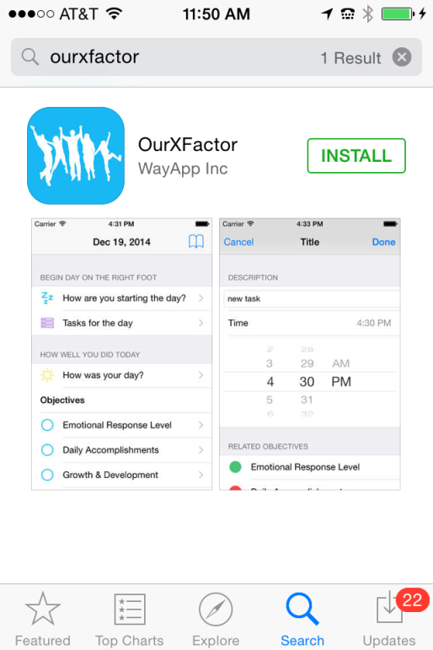
PROMOTION AND FUTURE STEPS
Web Presence:
- www.OurXFactor.com
Social Media Presence:
- Facebook: www.Facebook.com/OurXFactor and www.Facebook.com/Vandelanotte
- Twitter: @vandelanotte; https://twitter.com/Vandelanotte
- Instagram: https://instagram.com/ourxfactor/
- LinkedIn: https://www.linkedin.com/pub/xavier-van-de-lanotte/0/211/183
- YouTube: https://www.youtube.com/channel/UCukqWycRMl2w9v_EeKyImMg
- BLOGS: https://adashofgreatness.wordpress.com/author/xavier4life/ &
https://www.linkedin.com/today/author/520371
Press Release:
- Single release, attached, on July 25, 2014 (Distributed to 2,000 recipients)
Branding:
- Xavier Van de Lanotte (Life, Career and Relationship Coach, , Strategy Consultant and Speaker)
- Our X Factor: Insights and wisdom to maximize potential & minimize emotional and life hurdles
- Success and Happiness: Inspire life mustn’t be a struggle—enjoy more, achieve more, love more
- Mantra: We all have and X Factor…. Slogan: Bookmark every day with Success and Happiness
Principal Sales Channels:
- Amazon (eBook & Print on demand) (and Kindle)
- Barnes & Noble (eBook and Print on demand) (and Nook)
- iTunes and iBooks
- Google Play
- Direct Author Sales via SquareUp
- Page Publishing Author Page
Engagement:
- TV and Radio appearances, press articles and collaboration on other written works
- Book readings and signings at local book stores and community events
- Production and posting of inspirational videos to convey messages contained in the book
- Posting of inspirational quotes and blogs on FB, Twitter, LinkedIn and popular blog sites
- Round table and one-on-one discussions on topics contained in or related to the book
- Participate in community events, chambers and business associations as guest speaker, such as health and fitness centers, YMCA, local community events and groups for recovering addicts
Platforms (under development):
- Life, relationship and career coaching
- Corporate offer for coaching, seminars and inspirational speaking engagements
- Translation of book in Spanish, Portuguese, French, Dutch & German (Save the World initiative)
- Foundation of 2 altruistic non-for-profit causes (education; starvation)
- Presentations and open forum discussions in schools and universities
- Develop more books with the same perspectives, but focused on specific aspects
- Publish illustrated children books aimed at raising their self-esteem and confidence
- Develop and deliver school programs aimed at raising kids’ self-esteem and confidence,
- & school programs aimed at discovery of purpose and exploring dream goals and careers
For more information, speaking engagements, interviews or appearances, please contact:
Xavier Van de Lanotte
Address: 12801 SW 71st AVE
MIAMI, FL 33156 - U.S.A.
Phone: +1-305-972-4517
E-Mail: Xavier@OurXFactor.com
and Xavier@VXTConsulting.com
Ordering and additional book information at:
www.OurXFactor.com

